Task 1
Tesla Stock Price Prediction 📈 using Multiple Linear Regression
Linear Regression
I performed Simple Linear Regression by using the opening price as the independent variable and the closing price as the dependent variable. The model was trained to learn the relationship between these two variables, and a regression line was plotted along with the actual data points. This visualization helps show how well the opening price explains the closing price trend.
Code and their explanations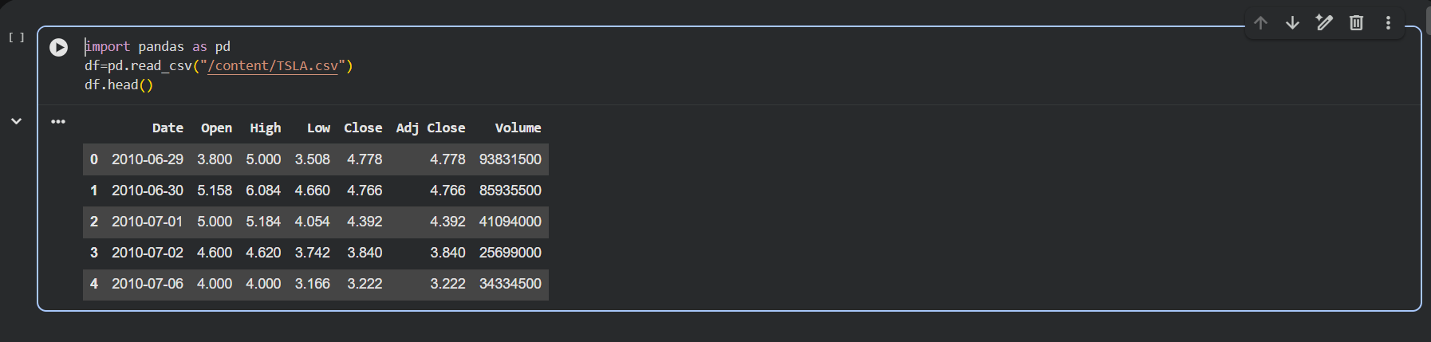
Explanation
I used the Pandas library to load the Tesla stock price dataset from a CSV file into a DataFrame. The head() function was used to display the first five rows of the dataset to understand its structure and key columns such as date, opening price, closing price, and trading volume. This step helped confirm that the data was loaded correctly for further analysis.
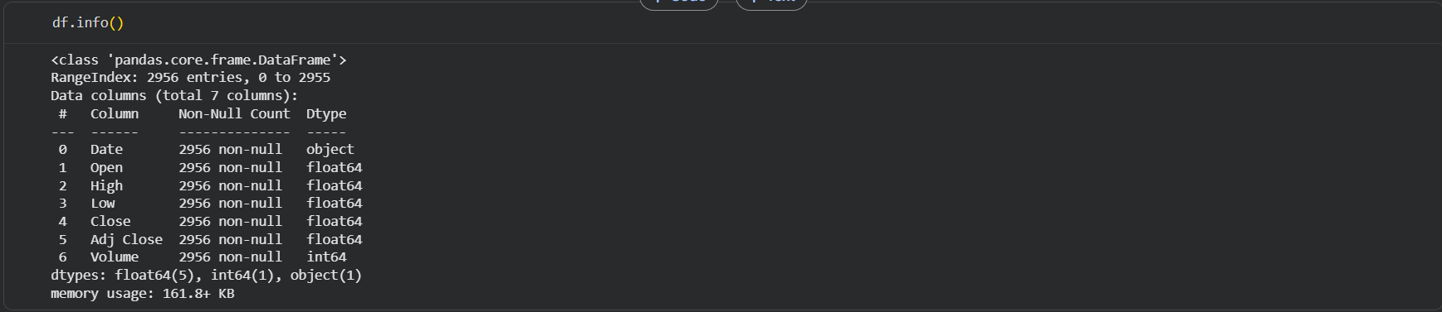
Explanation
I used the df.info() function to understand the structure of the dataset, including the number of rows, columns, and data types. It showed that the dataset contains 2956 entries with no missing values and includes numerical features like prices and volume. This step helped confirm that the data is complete and ready for further analysis.
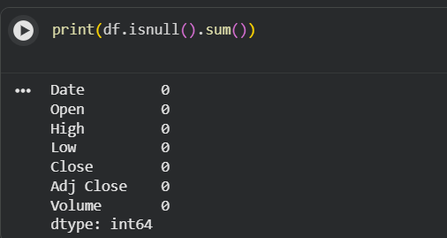
Explanation
I used df.isnull().sum() to check for missing values in each column of the dataset. The output shows zero missing values across all columns, confirming that the dataset is complete. This ensures that no additional data cleaning is required before analysis or modeling.
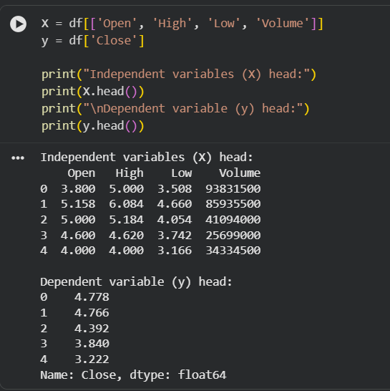
Explanation
I separated the dataset into independent variables (Open, High, Low, and Volume) and the dependent variable (Close). The independent variables represent the input features, while the closing price is the target value to be predicted. Displaying the first few rows helped verify that the data was split correctly.
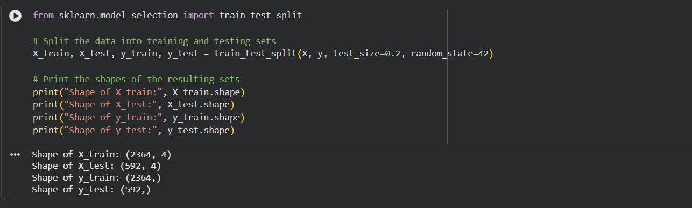
I split the dataset into training and testing sets using train_test_split, with 80% of the data used for training and 20% for testing. This helps evaluate the model’s performance on unseen data. Printing the shapes confirmed that the data was divided correctly.
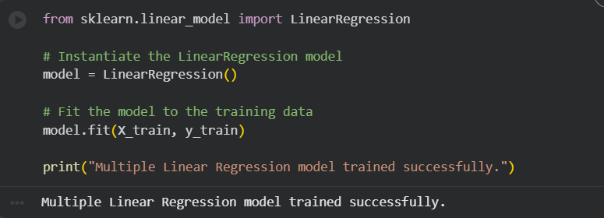
I created a Multiple Linear Regression model using the LinearRegression class from scikit-learn. The model was trained using the training dataset to learn the relationship between the input features and the closing stock price. This step prepared the model for making predictions on new data.
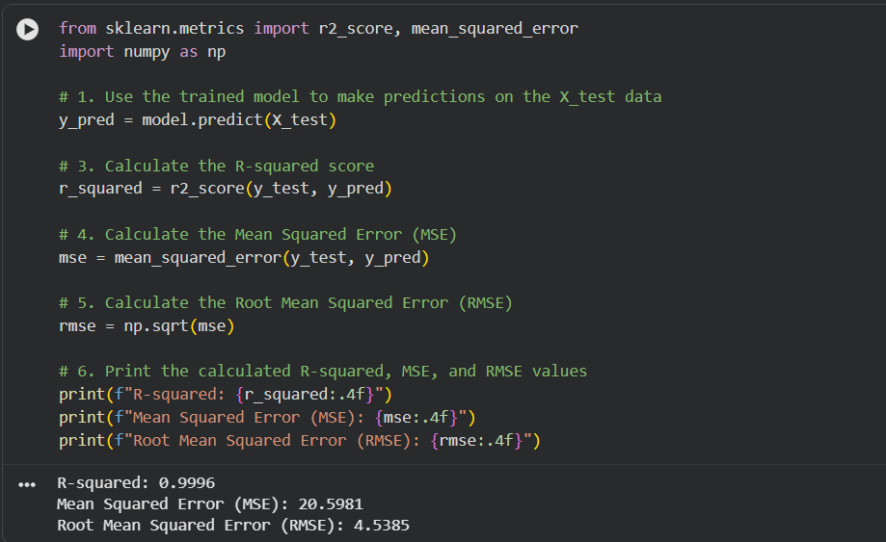
I evaluated the trained model by making predictions on the test dataset and measuring its performance using R-squared, Mean Squared Error (MSE), and Root Mean Squared Error (RMSE). The high R-squared value indicates that the model explains most of the variation in the closing price. The MSE and RMSE values show that the prediction errors are relatively small.
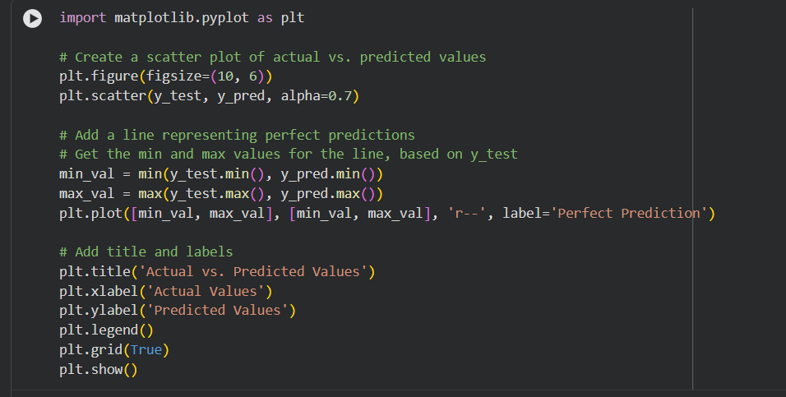
I plotted a scatter graph to compare the actual closing prices with the predicted values from the model. The diagonal dashed line represents perfect predictions, and most points lying close to this line indicate good model performance. This visualization helps clearly assess how accurate the model’s predictions are.
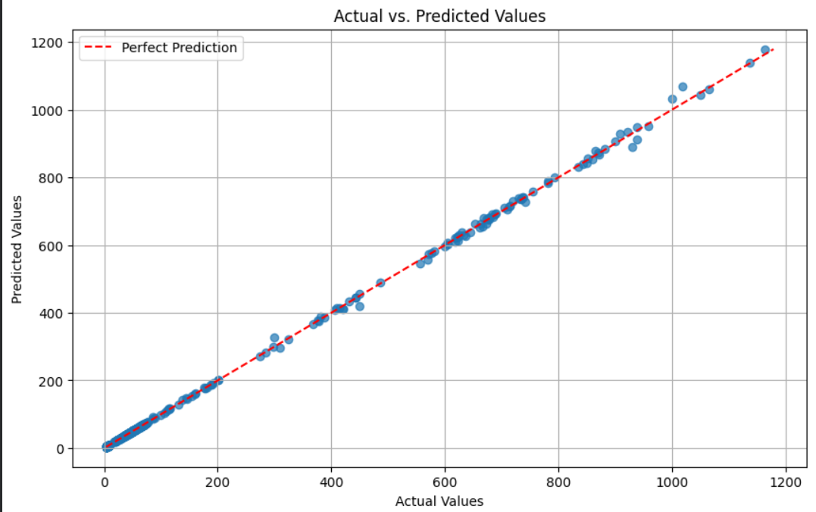
This graph compares the actual closing prices with the values predicted by the model. The dashed diagonal line represents perfect prediction, and most data points lie very close to this line, showing that the model’s predictions are highly accurate. Small deviations from the line indicate minor prediction errors.
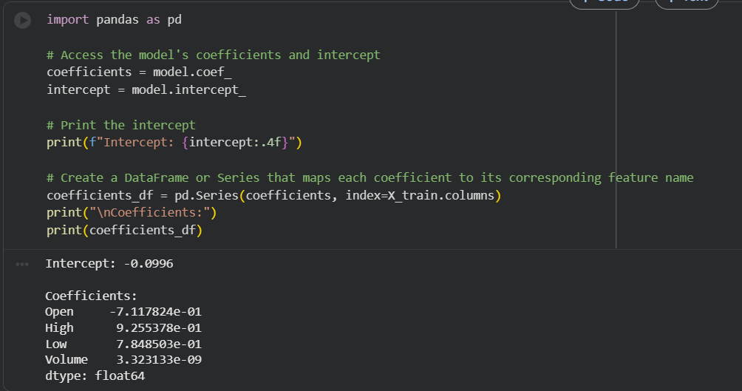
I extracted the intercept and coefficients from the trained Multiple Linear Regression model to understand how each feature affects the closing price. The intercept represents the base value when all input features are zero, while the coefficients show the contribution of Open, High, Low, and Volume to the prediction. This helps in interpreting the model’s behavior and feature importance.
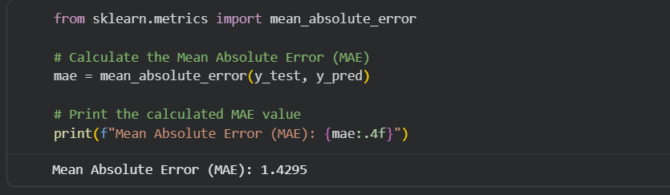
I calculated the Mean Absolute Error (MAE) to measure the average difference between the actual and predicted closing prices. MAE shows how far the predictions are from the real values without considering the direction of the error. A low MAE value indicates that the model’s predictions are highly accurate.
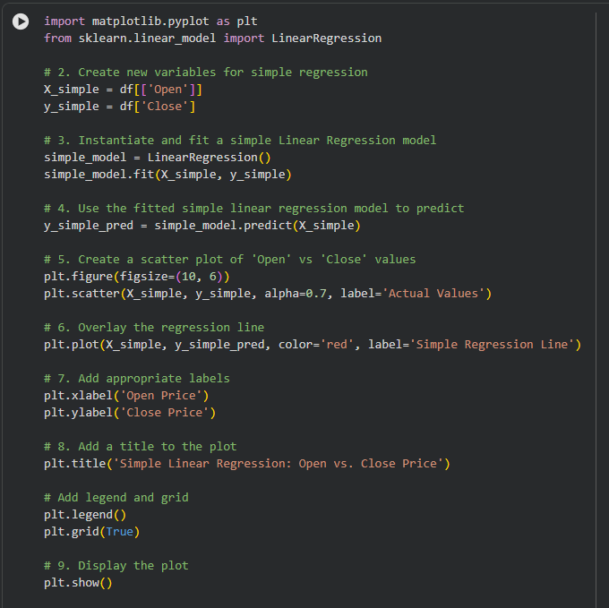
I performed simple linear regression by using the opening price as the independent variable and the closing price as the dependent variable. The model was trained and used to predict closing prices, and the results were visualized using a scatter plot with a fitted regression line. This graph helps show the direct relationship between opening and closing stock prices.

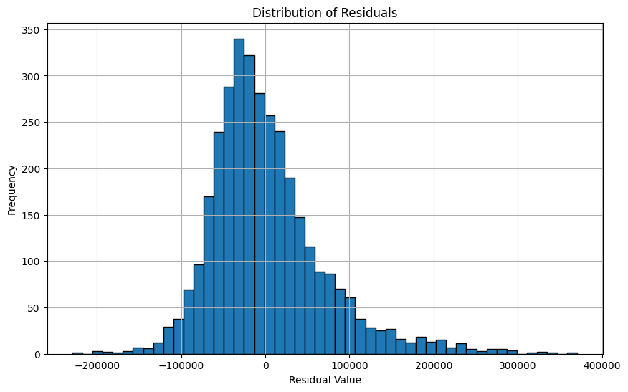
This histogram shows the distribution of residuals, which are the differences between the actual and predicted stock prices. Most residuals are centered around zero, indicating that the model’s predictions are generally accurate. The spread of the values shows the range and frequency of prediction errors.

